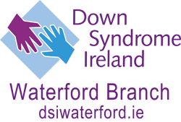

Don’t throw away your old Mobile Phone!!!

Waterford Branch of Down Syndrome Ireland are collecting old Mobile Phones.

Our adult literacy class needs an “Interactive White Board” If we can collect 500 phones we can get one free.

Help us by dropping in your phone to our office or contacting us

